

|  |
| --- |
| Group 3: Jumpy Jumpy Man |
| **Game Design Document**  Version #1.0 |
| Alejandro, Pintado Munoz (3xxxxxxxx) |
| Jin, Huang (301020707) |
| Michel, Daoud (301276345) |
| Sabeeh, Sabeeh (301184564) |
| Solaleh, Taheri (301306072) |
| Yuk Sing, Cheung (301230209) |

|  |
| --- |
| Jan 23th, 2023 |

**Table of Contents**

Version History 3

I. Game Type 4

II. MDA 4

III. Controls. 4

V. Screen Captures 8

VI. Characters/ Vehicles/ Camera 13

VII. Enemies (AI) 13

VIII. Weapons 14

IX. Sound Index 14

X. Art / Multimedia Index 15

# Version History

|  |  |  |  |
| --- | --- | --- | --- |
| **Name** | **Date** | **Reason For Changes** | **Version** |
| Initial GDD | Jan 25, 2023 | Creation of the initial GDD with concept and assets for platformer game | 1.0 |
| Updated GDD v2 | Feb 06, 2023 | Update of GDD based on recent changes to the game | 2.0 |
| Updated GDD v3 | March 3, 2023 | Update of GDD based on recent changes to the game | 3.0 |
| Updated GDD v4 | March 30, 2023 | Updated GDD based on recent changes to the game | 4.0 |
| Updated GDD v5 | April 03, 2023 | Updated GDD based on recent changes to the game | 5.0 |

# Game Type & Concept

Platform Runner is selected.

# 

# MDA

**Mechanics:**

The game mechanics in our 3D platformer involve jumping, running, and other movement based on powerups. The player must navigate through various levels, defeating hazards and collecting power-ups along the way. The player has a health bar that decreases when taking damage and can be replenished by collecting health pickups. The player can also collect coins and other items to increase their score.

**Dynamics:**

The dynamics of the game involves the player's interactions with the environment and enemies. As the player progresses through the levels, they will encounter various obstacles and enemies that they must overcome. The player must also manage their health. The game features a variety of different hazards, each with their own unique abilities and behaviors.

**Aesthetics:**

The aesthetic of the game is designed to be whimsical and colorful. The game features lush 3D environments, with bright and vibrant colors. The characters and enemies are designed to be cartoonish and expressive, adding to the light-hearted and fun atmosphere of the game. The game also features *a catchy and upbeat soundtrack that adds to the overall aesthetic experience.*

# Controls.

The game will be controlled using a combination of keyboard and mouse input. The specific input scheme is as follows:

**Keyboard:**

* W, A, S, D or arrow keys to move the character
* Spacebar to jump (x2 to double jump with power-up)
* Shift to run/dodge (with powerup)
* CTRL to crouch

**Mouse:**

* Move to look around
* Scroll wheel to zoom in/out

**Touch:**

* Left joystick for movement
* Right joystick for camera control
* Jump button implemented
* Pause Button implemented

1. **Levels and UI Sketch**

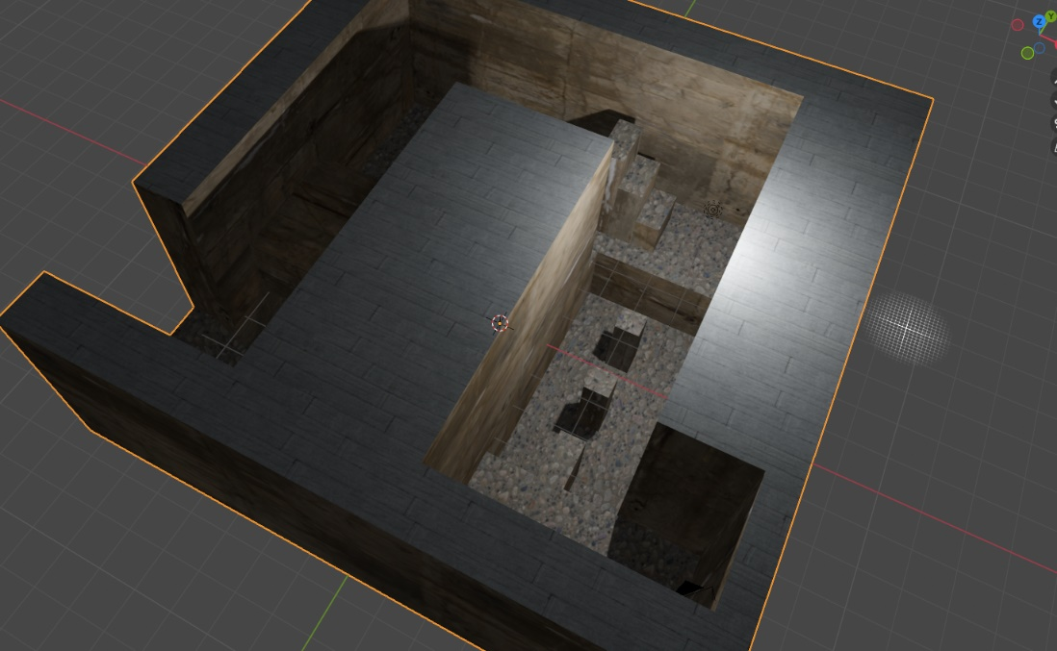

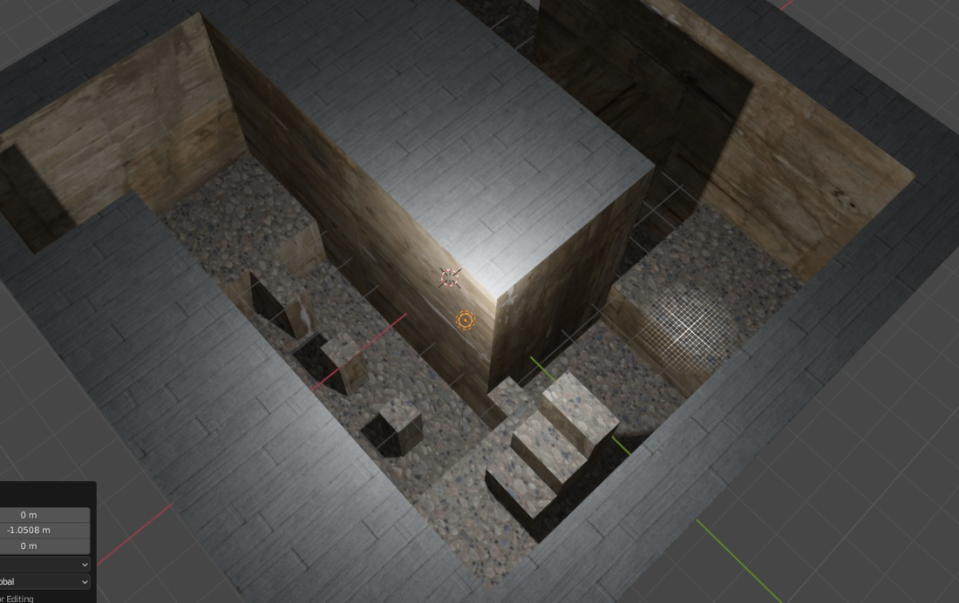

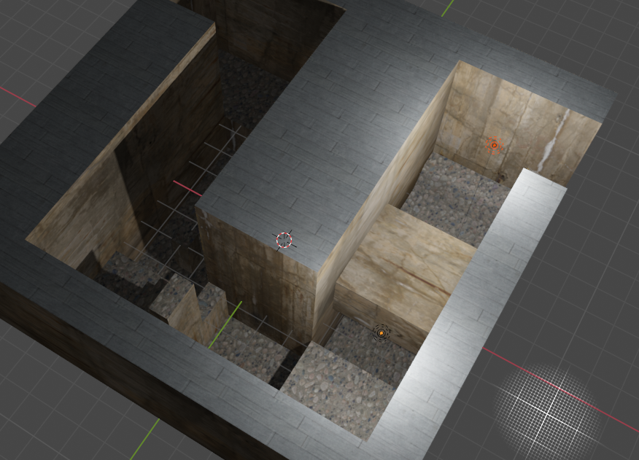

# Screen Captures (Later versions)

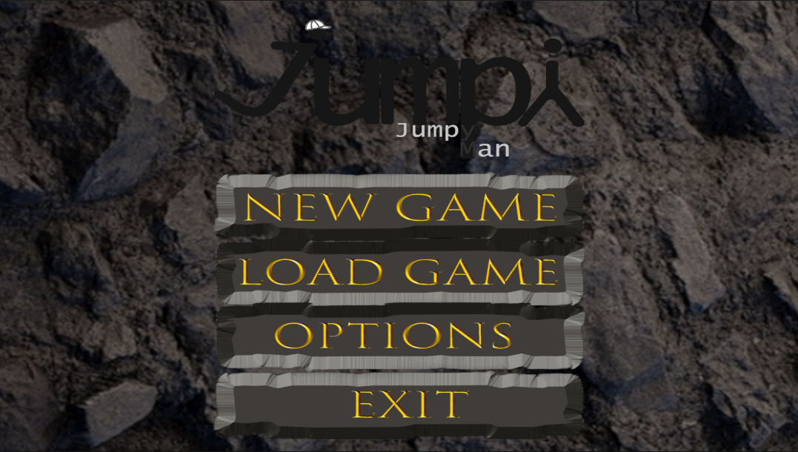

# Characters/ Vehicles/ Camera

The controls for the character are as follows:

* W, A, S, D or arrow keys to move the character
* Spacebar to jump (x2 to double jump with power-up)
* Speed will increase automatically on power pick-up
* CTRL to crouch
* Joysticks for Android
* Action buttons for android

The character also can use power-ups such as wall running, double jumping, and dodging. These power-ups can be found scattered throughout the levels or obtained from defeated enemies.

The camera follows the character's movement and can be controlled using the mouse. Player can use the mouse to look around.

The desired behavior for the character is to provide the player with a strong sense of immersion and control, allowing them to fully engage with the game world. The character's abilities and power-ups are designed to provide the player with new options and strategies, making the gameplay more exciting.

# Enemies (AI)

The game features various computer-controlled hazards, that the player must contend with. These hazards have unique behaviors and abilities that the player must learn to overcome.

* **Disappearing Hazards:** These hazards will appear and disappear at regular intervals. They are invulnerable while they are invisible but can be seen when they appear. The player must pay attention to their surroundings and anticipate the hazards' movements to avoid them.
* **Shattering Hazards:** These hazards are fragile and will break if being stood on for too long. The player must quickly move across these hazards to avoid falling through and taking damage.
* **Moving Hazards:** These hazards move along a set path, and the player must navigate around them to avoid collision. These hazards can be either slow or fast-moving, and the player must adjust their movements accordingly.

All hazards are designed to be challenging but fair, providing a sense of accomplishment when the player overcomes them. The desired behavior for these hazards is to increase the level of difficulty and engagement for the player. Object pooling will be implemented for areas with high amounts of hazards

# Weapons

In our 3D platformer, the player has access to a variety of power-ups that grant them some special abilities to be an aid in their journey. These power-ups can be found scattered throughout the levels or obtained from defeated enemies.

* Speed Up: This power-up allows the player to run faster for a limited time. This allows the player to progress through the levels and obstacles that otherwise would have been difficult.
* High Jump: This power-up allows the player to perform a higher jump. This allows the player to reach higher platforms and navigate the levels with greater ease.

Each power-up has a limited duration and can only be used in certain amount of time before it needs to be collected again. The desired behavior for these power-ups is to provide the player with new abilities and options, making the gameplay more dynamic and exciting.

# Sound Index

|  |  |  |  |  |
| --- | --- | --- | --- | --- |
| **Sound Effect** | **Category** | **Description** | **Filename** | **Format** |
| Menu Selection | Menu | Sound of item being hovered | Menu_Open_and_Click | WAV |
| Jump | Character | Sound of player Jumping | Jump | WAV |
| Death | Character | Sound of player dying upon contact with hazard | Hurt | WAV |
| Pick up Item | Extra | Sound of player picking up powerup | Pick_up_Item | WAV |

# Art / Multimedia Index

|  |  |  |  |
| --- | --- | --- | --- |
| Texture | Description | Filename | Origin |
| Ground | Rocky texture for ground of the level |  | Assets acquired in class |
| Roof | Smooth floor board texture for the roof tiles |  | Assets acquired in class |
| Wall | Smooth concrete texture for the wall |  | Assets acquired in class |